Business Requirement Document

***Requirement ID ART_001***

***Title: B2C-Insurance Module***

***Prepared by:*** *Sangeetha*

***Prepared for:*** *Al Rostamani Travels*

***Date Submitted:*** *09-Jul-2020*

***Document Number:*** *ART_001*

***Requirement ID ART_001***

***Title: B2C-Flight Module***

***Prepared by:*** *Sangeetha*

***Prepared for:*** *Al Rostamani Travels*

***Date Submitted:*** *09-Jul-2020*

***Document Number:*** *ART_001*

Change history

|  |  |  |  |
| --- | --- | --- | --- |
| *Ver.#* | *Date* | *Author* | *Change Description* |
| 1 | 16Jul20 | Sangeetha | Draft |
|  |  |  |  |
|  |  |  |  |
|  |  |  |  |
|  |  |  |  |

ART - Insurance Module

**INTRODUCTION:**

This document explains the functional flow of insurance module. The insurance module has below mentioned features.

# FEATURE:

* Search insurance
* Search result- Choose/Modify insurance
* Review insurance
* Pay and book

# LOGIN PROCESS

* The user shall be able to purchase a insurance as Registered logged in user or as a guest

# SEARCH INSURANCE

In the “Search insurance”, the user can search their insurance plan by feeding required data in search screen.

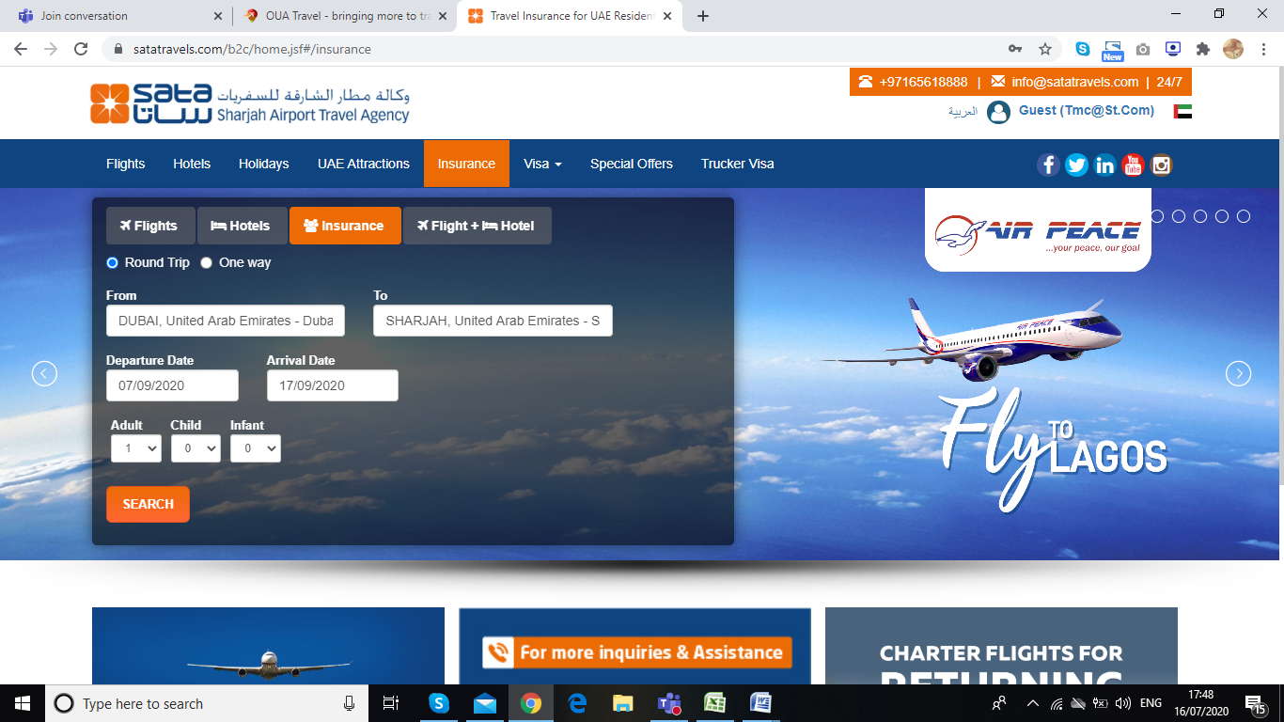

FIG 1. SEARCH SCREEN

|  |  |  |
| --- | --- | --- |
| Fields | Field Type | Description |
| From Airport | Text Box(**TB)**,Mandatory**(M)** | The field should accept the Airport code and the city name. When the user enters the airport code, then the airport should be displayed. Auto population of airport name should be done on pressing the tab button. |
| To Airport | Text Box(**TB)**,Mandatory**(M)** | The field should accept the Airport code and the city name. When the user enters the airport code, then the airport should be displayed. Auto population of airport name should be done on pressing the tab button. |
| Date Selection | Calendar Field, Mandatory**(M)** | After clicking the calendar icon,The calendar should populate the from date and to date. And after selecting the dates, it should show the total duration of the selected dates.  **Calendar date selection should be restricted to 320 days (configurable according to the business rules)** |
| Passenger Field(Adult and child) | Drop-Down**(DD)**, Mandatory**(M)** | This filed allows user to enter the count.of Adult and child.  **Passenger (Adult+Child) count should not together should not exceed 9** |

# Search Loading Mechanism:

Once the user searches, an intermediate search loading page shall be viewed with the searched data until the results are displayed. This page can be used for advertising as well. Once the system receives the response from the supplier, the system shall show all the hotel results together (Max 15 seconds).

# SEARCH RESULTS – CHOOSE / MODIFY INSURANCE

This screen will provide availabe Insurance policy options under various plan that user should be able to select suitable plan and expand further to get details

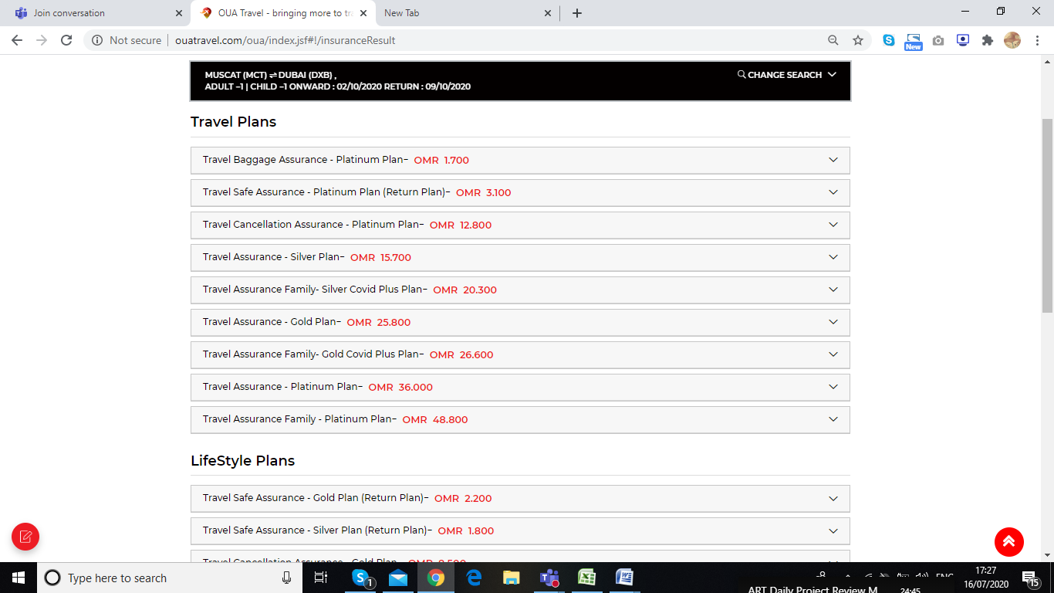

FIG 2. INSURANCE REVIEW PAGE

# Insurance Details

User Once expand plans the details of plan and terms & conditions should be visible .user can select the require plan and book

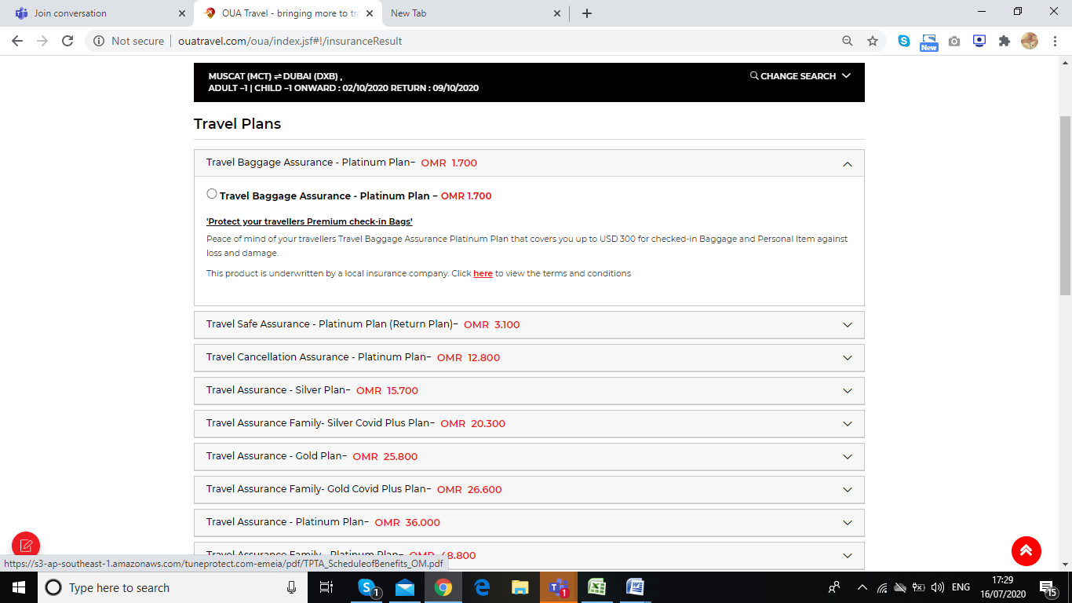

FIG 3. INSURANCE DETAILS

# MODIFY INSURANCE

The modify search section allows the user to change their search criteria as per their need.

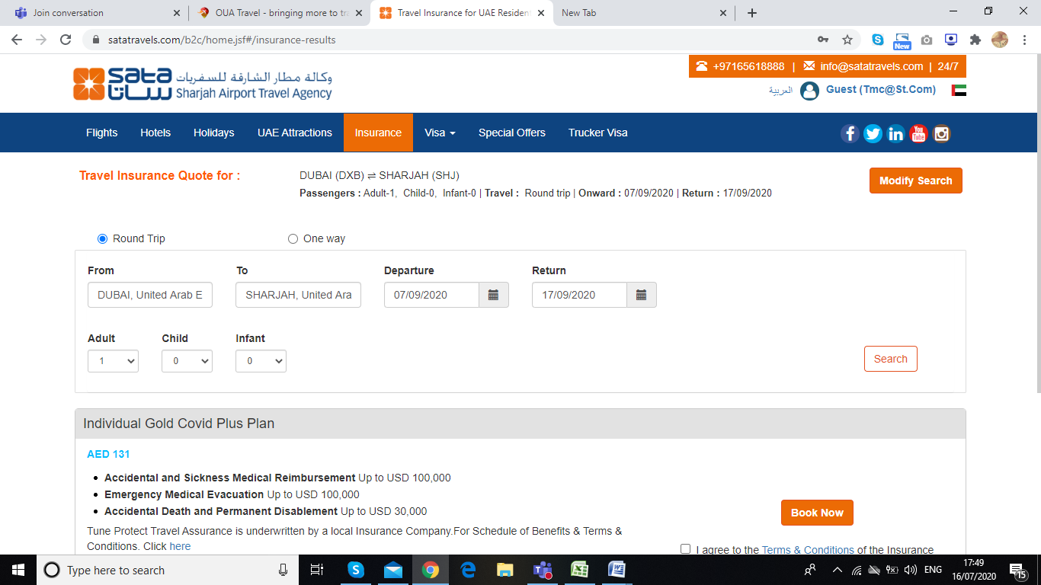

FIG 4. MODIFY INSURANCE

# INSURANCE REVIEW PAGE

This screen display selected insurance plan & price details with terms and conditions along with Pax and Payment option in same page

# INSURANCE REVIEW

This screen display the details of plan and login option for registered customers and Guest users / Option for Guest to register

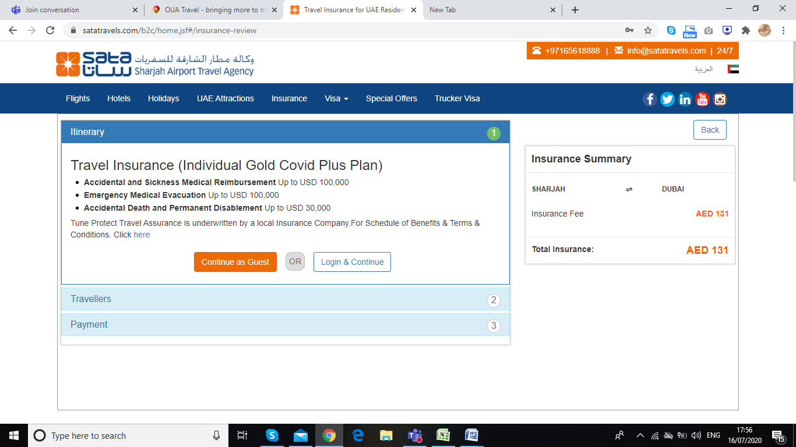

FIG 6.Itinerary screen

* Booking Flow:
  + Guest User:
    - If the user has come as a guest user, then in the Itinerary screen the user shall have two options (Continue as Guest or Login & Continue). Ref fig 6
    - The user shall click the button Continue as Guest.
    - The user shall enter their Email and clicks the Continue.
    - The user shall add the Guest details and checks the terms and conditions and the clicks the Proceed button to go to the payment gateway screen.
  + Logged In User (Login from the Home page).
    - In this case, the user shall login from the home page.
    - The user enters the search criteria and clicks on the search button. The system shall send requests to the suppliers.
    - The system shall show the results
    - The user shall select the insurance and then proceeds to the review page
    - The user shall be able to create a new guest or if the user wants to add his/her details then the user shall select the option “Use my profile”.
    - Or if the user wants to book for his/her dependencies then the user shall select from my traveller profiles. The system shall show the dependencies profiles and the user shall add the guest to the booking.
    - The user shall add the Guest details and checks the terms and conditions and the clicks the Proceed button to go to the payment gateway screen.
  + Guest User and Login from the Booking review screen:
    - If the user has come as a guest user, then in the Itinerary screen the user shall have two options (Continue as Guest or Login & Continue).
    - If the user has a B2C User ID login and password, then the User shall click the Login & Continue. The system shall redirect the user to the login screen, the user shall enter the Username and password and then will be redirected to the Itinerary screen as a logged in User.
    - The user shall be able to create a new guest or if the user wants to add his/her details then the user shall select the option “Use my profile/info”.
    - Or if the user wants to book for his/her dependencies then the user shall select from my traveller profiles. The system shall show the dependencies profiles and the user shall add the guest to the booking.
    - The user shall add the Guest details and checks the terms and conditions and the clicks the Proceed button to go to the payment gateway screen.

# TRAVELLERS

Here the user can enter their passenger details. This section should have fields as mentioned below

* Salutation
* Given Name
* Surname
* DOB
* Contact Number - With Country code Drop/Type populate

The country name and code (in brackets)

Data should be populated when the user types the country name or country code and the field should be drop down list as well.

* Email ID,
* Nationality field
* Passport Number and
* Passport Expiry date

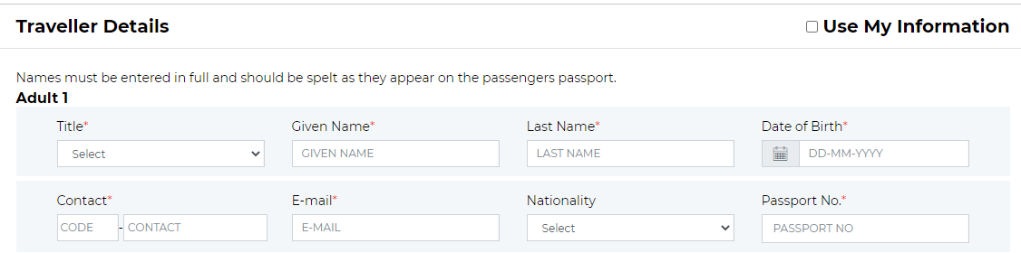

FIG 7. Travellers

# Payment

This section allows the user to pay for their booking by providing their card details and proceed with pay.

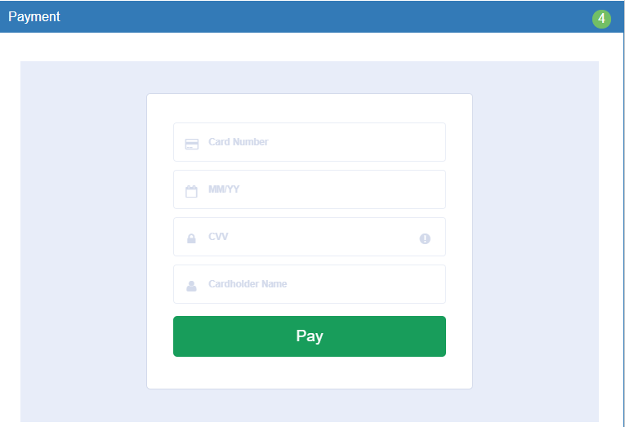

* + Payment And Booking Confirmation Process:
    - The user shall enter the credit card details and then clicks the pay button.
    - The user shall be redirected to the payment gateway system to confirm the payment.
    - On successful payment

|  |  |  |
| --- | --- | --- |
| Prepared by | Signature | Date |
| Sangeetha  Convergent Technology Solutions |  |  |
| Approved by | Signature | Date |
|  |  |  |